**Code:**

import com.ibm.aglet.*;

public class Pallindrome extends Aglet

{

public void run()

{

int number1=989,r,sum=0,temp;

int number2 = number1;

temp=number1;

while(number1>0)

{

r=number1%10;

sum=(sum*10)+r;

number1=number1/10;

}

if(temp==sum)

System.out.println(number2+" is a palindrome number.");

else

System.out.println(number2+" is not a palindrome number."); }

}

**Output:**

Aglet window after creating the application on first machine:

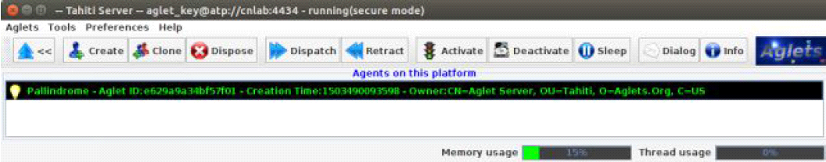

Aglet window of machine 2 after receiving process from machine 1:

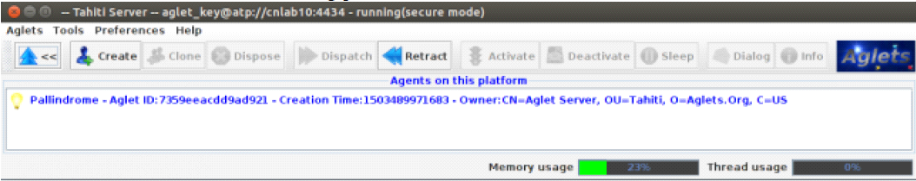

Output displayed on machine 2:

